**LIGHTING HARDWARE**

The main visible feature of the Guardian Cycle device was that it could physically display indicators, a breaking light and an emergency alarm light in the event of a fall. It was decided that for the presentation a working proof of concept was required.

At this stage it was certain that the breaking light, or more accurately, a slowing down light, could be devised to work with the M5Stack accelerometers. The indicators would probably be controlled via a left – right switch mounted on the handle-bars of the bicycle, similar to a motorcycle indicator system. However for the prototype it was decided to use the buttons built in to the M5Stack, alongside a button activated Arduino system – a back-up for the presentation that would circumnavigate the battery life of the M5Stack.

Whilst a 5x5 LED matrix is available for the M5Stack, the ATOM Matrix ESP32 PICO, it was only available from international sellers, and a decision was taken that the time lost waiting for delivery was too great, so the team moved forward on alternative plans.

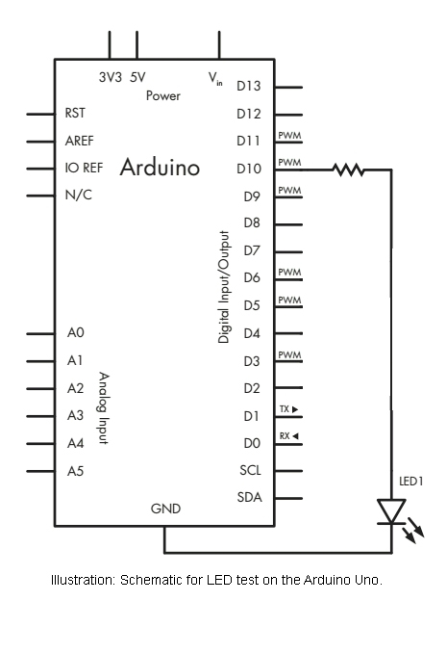

In the first instance, it was important to determine hat a simple LED system could be devised and wired into a M5Stack. A simple single LED system was created using an Arduino Uno and a 220 ohm resistor and a breadboard, with test code was run to flash the LED. The code and the wiring was then transferred to the M5Sack, which worked perfectly.

The code (test-m5-output.ino in the github repository) simply alternated a high/low write signal to Digital Pin 10 – and thereby turned the LED on and off.

At this point a 5x5 RGB LED matrix from Pimoroni was ordered; the idea being that it could be housed within a box like structure on the back of a helmet and be programmed to demonstrate the various lighting states.

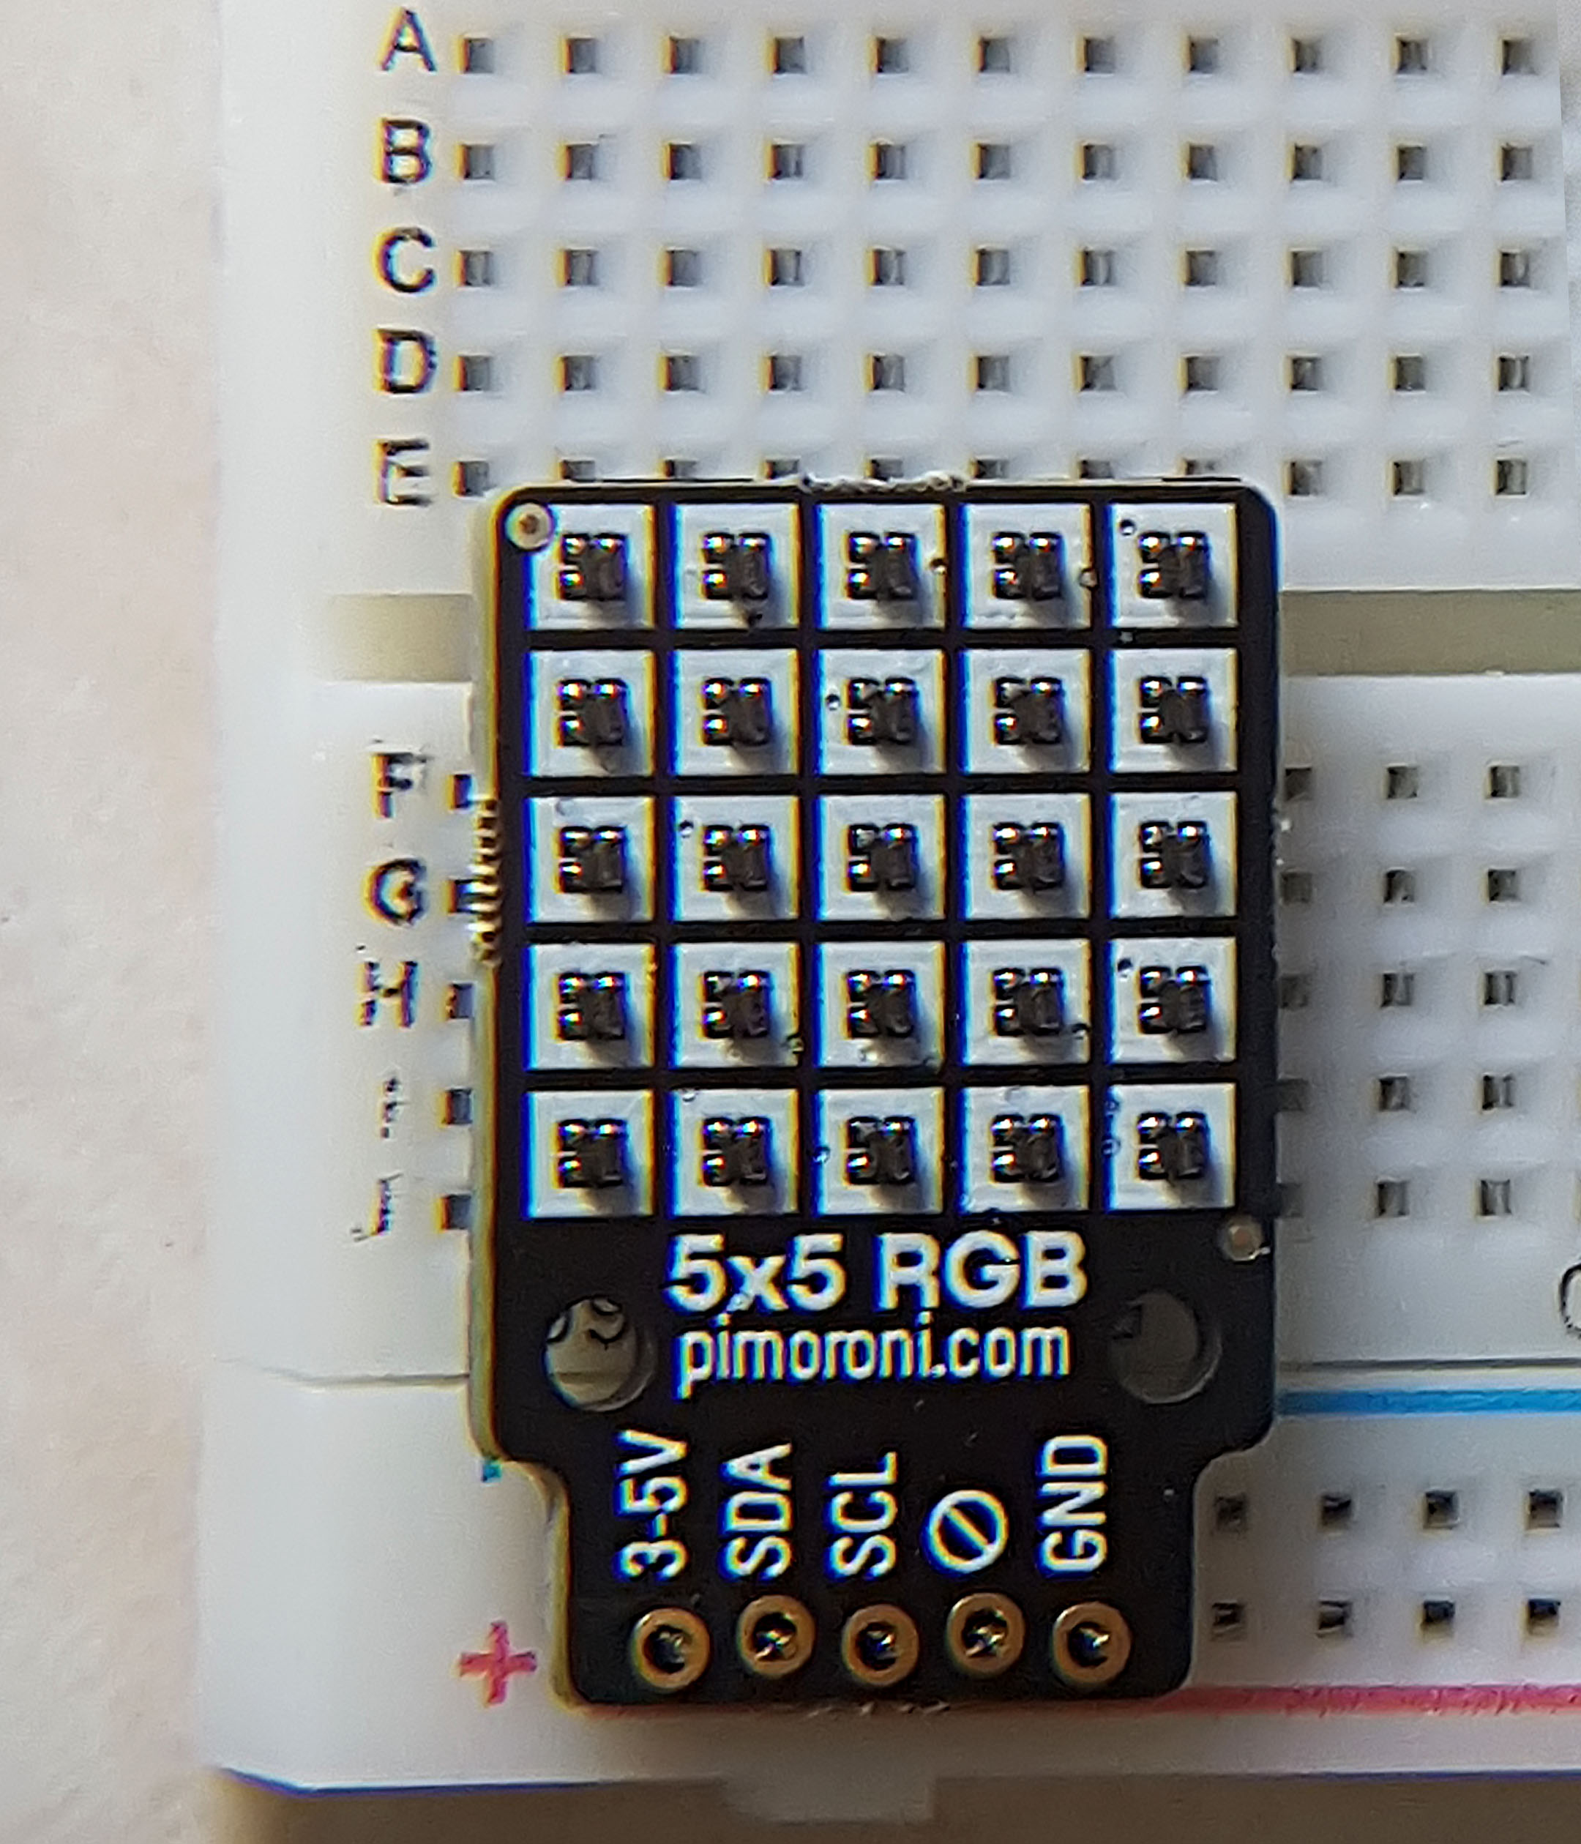

It was intended that through coding the accelerometers within the M5Stack a fall light state could be generated, but that as a safety backup, an Arduino with a simple switch could generate that state within the presentation.

Therefore the first point of call was coding the Arduino to display all the required lighting states – a left and right indicator, a break light and the emergency light. Unfortunately this proved to be very difficult as although the matrix was described as Arduino compatible the only libraries that proved tro work properly with it were solely available on the Raspberry Pi or required Python to be used. At this point, with a code base for other systems already developed, we continued to use the Pimoroni with rather inelegant code (RGB5x5_v2.ino).

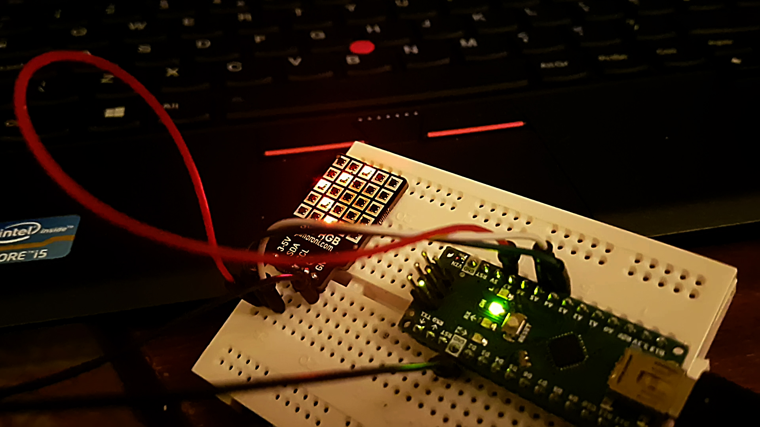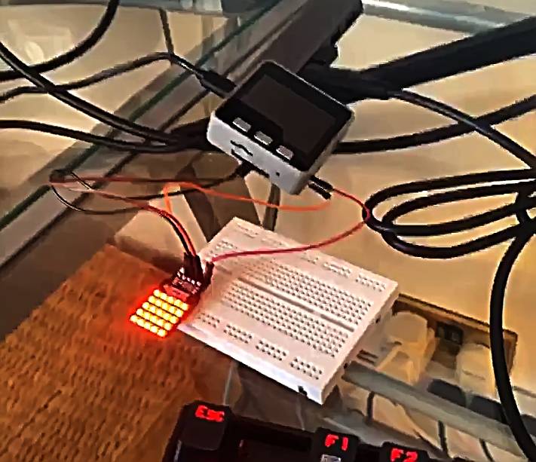

Photographs: Pimoroni Matrix demonstrating left turn (Arduino Nano) and break light (M5Stack).

Photograph (previous page): Pimoroni RGB Matrix on a breadboard.

With the lighting states working on both the Arduino Uno/Nano and the M5Stack, the next part in the process was to enable the states to be selected through the M5 button states; with a back-up system of an Arduino using buttons to replicate this process if required in the presentation.

The photo-shoot for the website and adverts, proved that the Pimoroni matrix was ineffective in daylight, and whilst it may work within the confines of a presentation, it was still rather anemic. At this point the hardware design moved towards two separate goals, (i) what the actual device upon the helmet would look like and (ii) could we wire in an array of LED strips to create a more powerful device for the presentation.

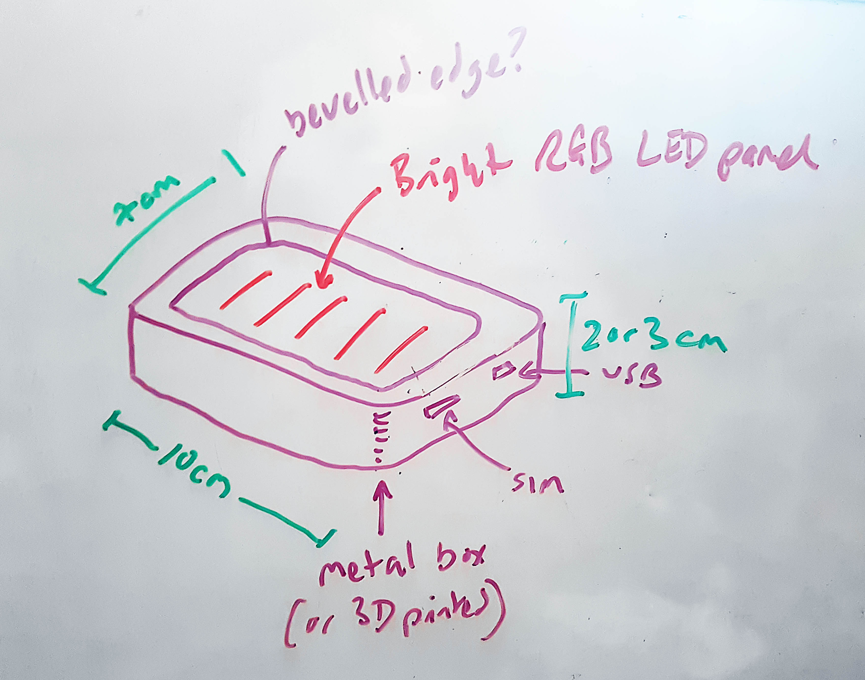

i) the device itself needed to be a lightbox, carrying the LEDs and battery. If it was the genuine final device it would need to incorporate a micro-USB port for charging (and attaching to a computer), and a SIM card port. There would also need to be room for accelerometers, GPS, wifi etc.

A simple design was built in 3D using Blender software:

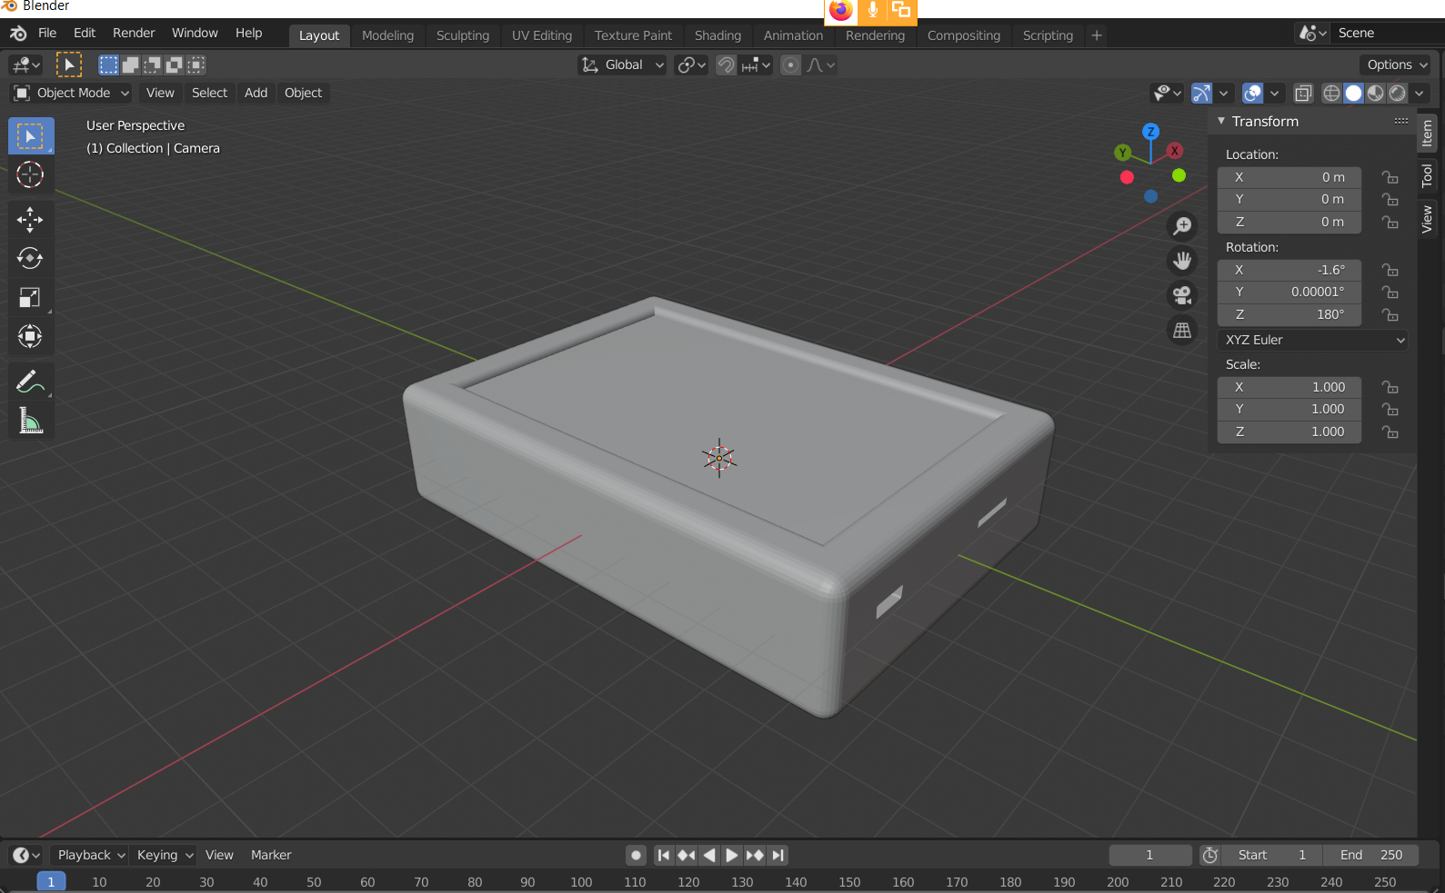

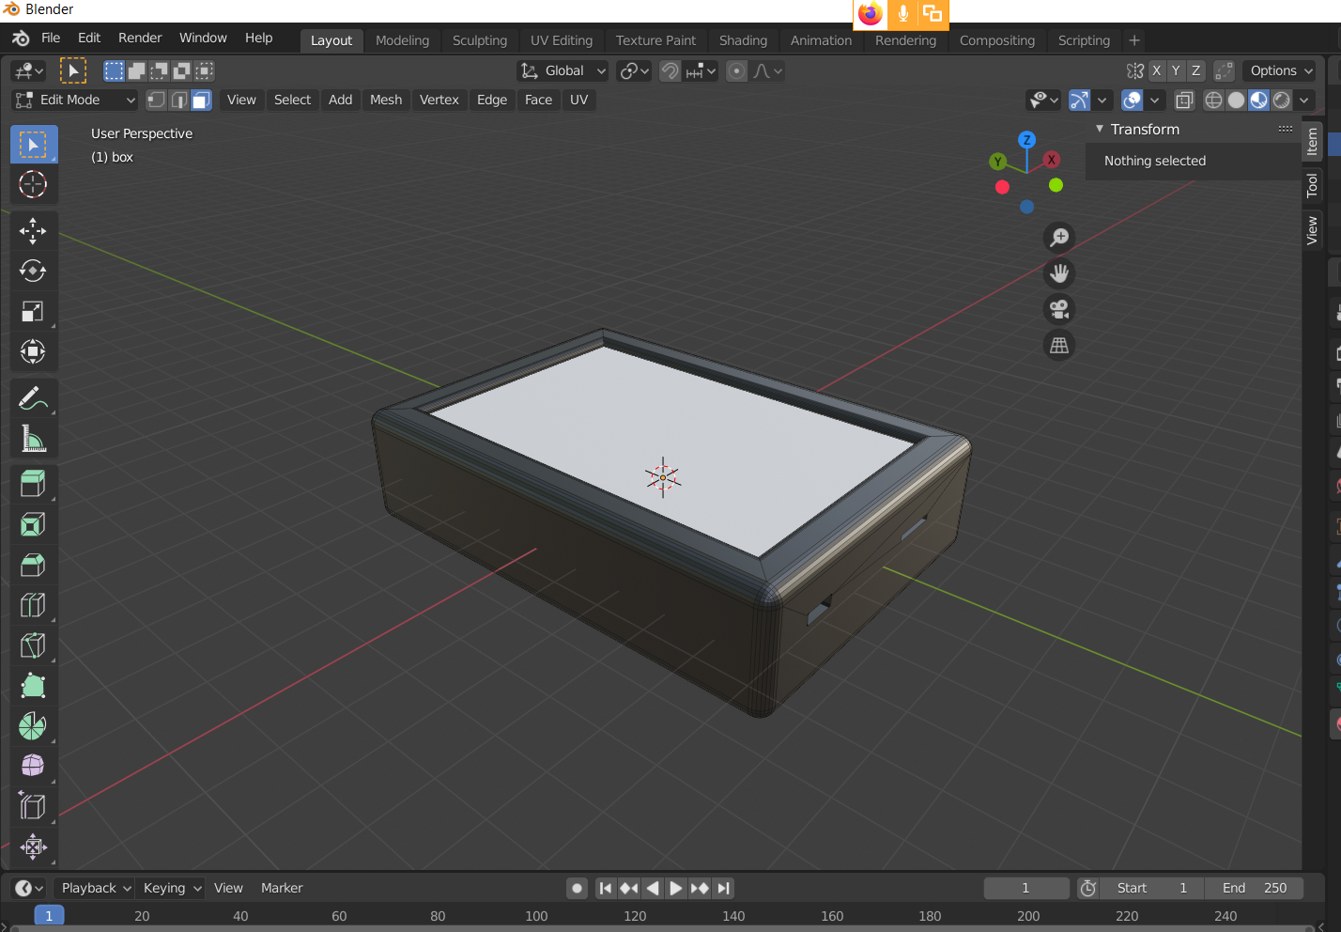

Ultimately it was envisaged that the back of the box would have the Guardian Cycle logo engraved in it, and the area around the diffused (white) light panel would be engraved with the model number and/or the Guardian Cycle name.

The advantage of building this in 3D within Blender was that the device could be sent to a 3D printer to be manufactured (to do this the light panel would be removed from the model, and that area would be extruded all the way down. Interior fittings would have been devised to hold the LEDs etc in place).

At this stage a 3D printed prototype would only have consisted of the working lighting states – all other functions would have been provided by the M5Stack.

ii) Unfortunately at this point the Corvid-19 situation meant that a physical presentation was no longer required. Therefore the LED RGB strip system was not built, nor indeed was there a need to 3D print the device.

However, the 3D model could be used to create product advertising, as shown overleaf with a first draft of a technical spec. Note at this point the relationship with the M5 Wearable had not been determined, so it does not feature on the technical sheet overleaf.

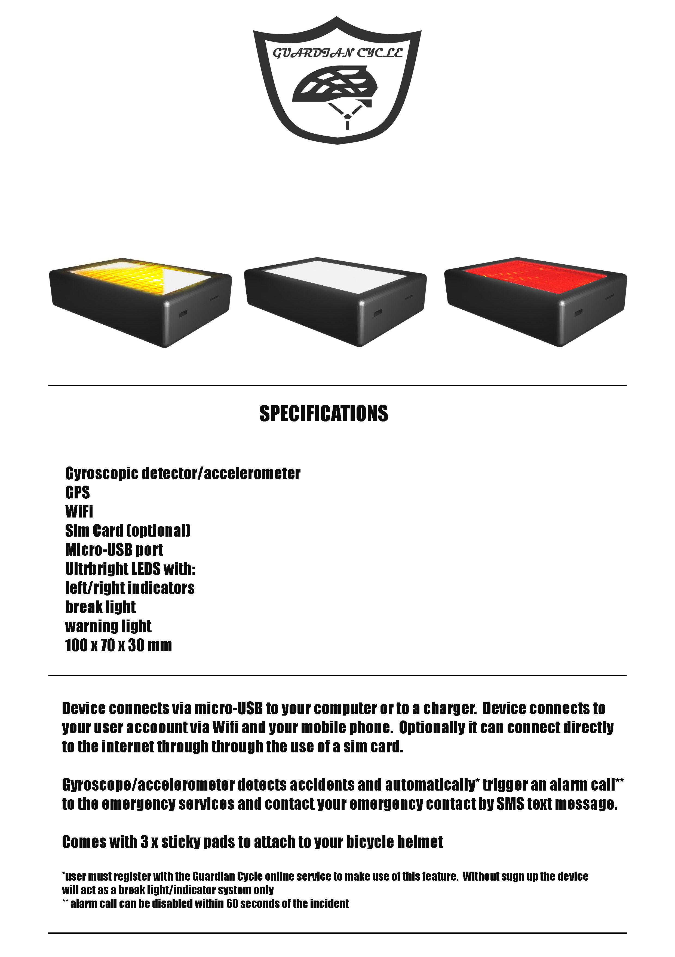Technical spec advert created using Blender model with additional touches in Adobe Photoshop.